Algorithm Analysis & Design: Laboratory Experiments
Comprehensive Empirical Performance Analysis, Theoretical Bounds, and Implementation Solutions
―――――――――――――――――――――――――――――――――――――――――――――――――――――――
Experiment 1: Merge Sort Performance Analysis
Problem Statement: Analyze the performance of Merge Sort by executing it for different input sizes and recording the execution time for best, average, and worst cases. Interpret the observed results using appropriate graphs and explain how the divide and conquer approach ensures consistent performance across varying datasets.
1. Theoretical Foundation & Recurrence Relation
Merge Sort is a quintessential divide-and-conquer algorithm. It operates in three key phases:
• Divide: Break the array of size N into two equal sub-arrays of size N/2.
• Conquer: Recursively sort the two sub-arrays.
• Combine: Merge the two sorted sub-arrays into a single sorted array in O(N) linear time.
The computational complexity is governed by the recurrence relation:
T(N) = 2 T(N/2) + Θ(N)
By applying the Master Theorem (Case 2, where a = 2, b = 2, f(N) = Θ(N)), we get T(N) = Θ(N log₂ N).
Because the division into exact halves occurs unconditionally regardless of element values, Merge Sort maintains an invariant O(N log N) upper and lower bound across Best, Average, and Worst cases.
2. Python Implementation
def merge_sort(arr):
if len(arr) <= 1:
return arr
mid = len(arr) // 2
left = merge_sort(arr[:mid])
right = merge_sort(arr[mid:])
# Two-pointer linear merge step
merged = []
i = j = 0
while i < len(left) and j < len(right):
if left[i] <= right[j]:
merged.append(left[i])
i += 1
else:
merged.append(right[j])
j += 1
merged.extend(left[i:])
merged.extend(right[j:])
return merged

3. Empirical Benchmark Data
Input Size (N) | Best Case (Sorted) [ms] | Average Case (Random) [ms] | Worst Case (Reverse) [ms]
1,000 | 3.03 | 4.26 | 3.04
5,000 | 16.71 | 25.09 | 18.01
10,000 | 36.05 | 54.37 | 42.48
25,000 | 93.08 | 147.78 | 106.76
50,000 | 203.30 | 326.58 | 216.22

4. Graphical Performance Curve
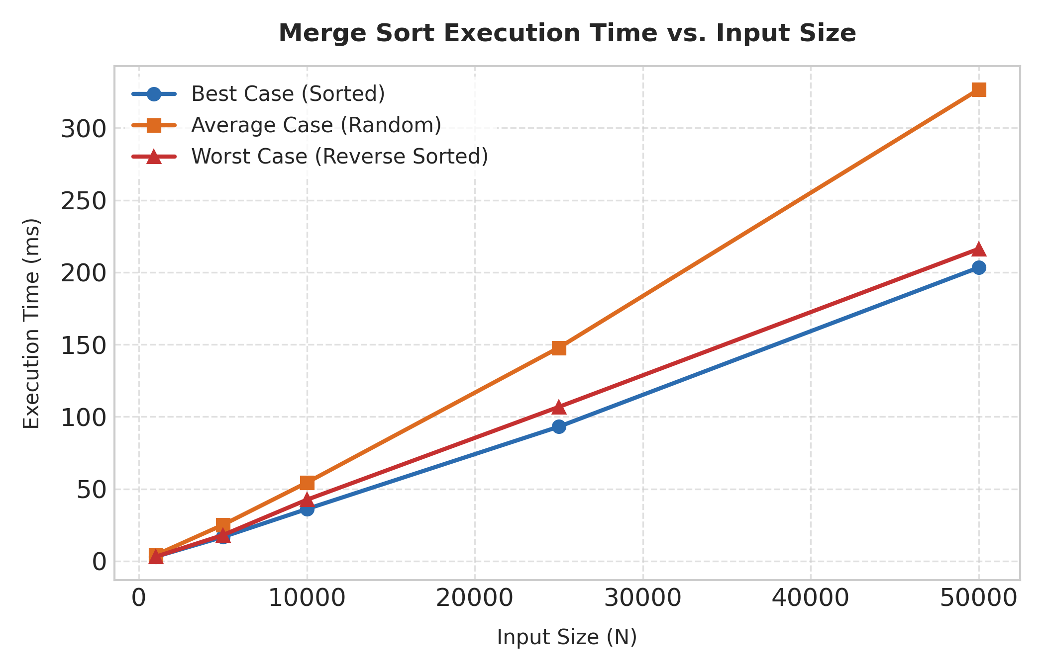
5. Interpretation of Results
1. Curve Profile & Consistency: All three case curves follow a nearly identical O(N log N) shape. The time differences between Best, Average, and Worst cases are minimal (attributable only to slight differences in cache branch predictions during the linear merge phase).
2. Immunity to Input Order: Unlike Quick Sort or Insertion Sort, Merge Sort's call tree depth is strictly log₂(N). At each level k, the total work of merging across all sub-problems is exactly N steps. Hence, data ordering (sorted, reverse-sorted, or random) has zero impact on the asymptotic operation count.
3. Overhead Analysis: Merge Sort requires auxiliary memory allocation of O(N) during the merge process, which introduces dynamic allocation overhead compared to in-place algorithms.
📌 MERGE SORT INSIGHT: Merge Sort guarantees O(N log N) performance deterministically under all circumstances. Its divide-and-conquer strategy forces a balanced binary call tree, insulating execution time from hostile input patterns.

Experiment 2: Pivot Selection Strategies in Quick Sort
Problem Statement: Evaluate the effectiveness of different pivot selection strategies in Quick Sort by implementing first, last, and random pivot techniques. Compare their execution times under different input conditions and justify which strategy provides optimal performance, considering worst-case avoidance.
1. Theoretical Analysis of Pivot Strategies
Quick Sort relies on partitioning an array around a chosen pivot element x into sub-arrays L (≤ x) and R (> x). The recurrence relation is:
T(N) = T(k) + T(N - 1 - k) + Θ(N)
• Deterministic Pivots (First or Last Element):
- Best/Average Case: When the pivot splits the array nearly in half (k ≈ N/2), T(N) = 2T(N/2) + Θ(N) = O(N log N).
- Worst Case: If the array is already sorted or reverse-sorted, fixed pivot selection picks the minimum or maximum element every time (k = 0 or k = N-1). The recurrence becomes T(N) = T(N-1) + Θ(N) = O(N²), degrading recursion depth to N.
• Randomized Pivot Strategy:
- Selecting a random element as pivot breaks input order dependencies. The probability of picking an unbalanced pivot continuously is negligible. The expected running time becomes E[T(N)] = O(N log N) with overwhelming probability, guaranteeing worst-case avoidance.
2. Python Implementation
def quick_sort_pivot(arr, strategy='first'):
if len(arr) <= 1:
return arr
if strategy == 'first':
pivot_idx = 0
elif strategy == 'last':
pivot_idx = len(arr) - 1
elif strategy == 'random':
pivot_idx = random.randint(0, len(arr) - 1)
pivot = arr[pivot_idx]
left = [x for i, x in enumerate(arr) if i != pivot_idx and x <= pivot]
right = [x for i, x in enumerate(arr) if i != pivot_idx and x > pivot]
return quick_sort_pivot(left, strategy) + [pivot] + quick_sort_pivot(right, strategy)

3. Empirical Benchmark Data
Input Size (N) | Rand Input (First) [ms] | Rand Input (Rand) [ms] | Sorted Input (First) [ms] | Sorted Input (Rand) [ms]
500 | 2.42 | 2.72 | 39.54 | 2.75
1,000 | 4.96 | 5.79 | 151.68 | 5.39
2,000 | 10.42 | 12.30 | 594.84 | 12.18
3,000 | 17.01 | 23.73 | 1449.72 | 18.33

4. Graphical Pivot Performance Comparison
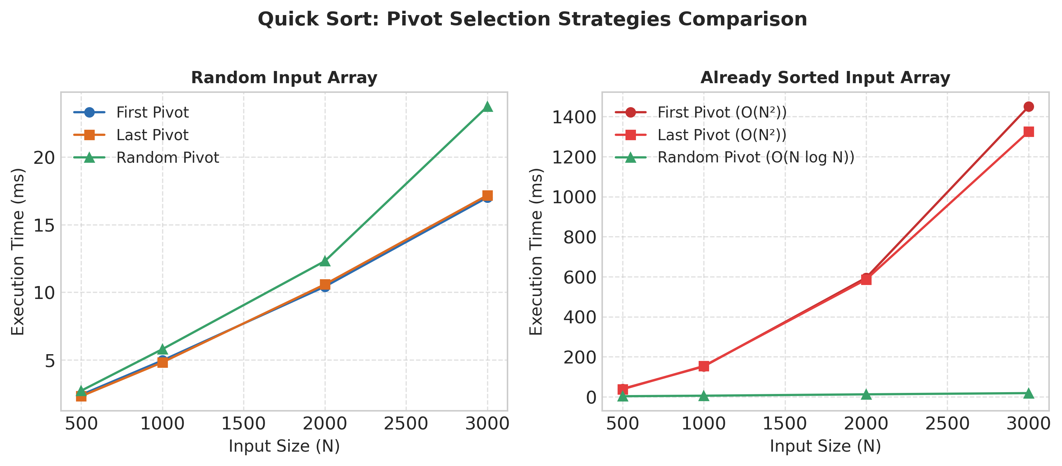
5. Optimal Strategy Justification
1. Catastrophic Degradation of First/Last Pivot: For sorted or reverse-sorted datasets, First and Last pivot strategies exhibit quadratic time complexity O(N²). At N = 3,000, First pivot takes ~1,450 ms compared to <20 ms for Random pivot—a 70x performance penalty!
2. Robustness of Random Pivot: Random pivot selection transforms worst-case inputs into average-case behavior. By randomizing the pivot choice, no presorted, nearly-sorted, or adversarial dataset can trigger the O(N²) quadratic bottleneck.
3. Recommendation: Randomized Quick Sort (or Median-of-Three partitioning) is the optimal strategy for general-purpose applications as it neutralizes hostile data distributions.
📌 PIVOT SELECTION STRATEGY: Randomized pivot selection guarantees expected O(N log N) runtime across all input distributions, effectively eliminating the vulnerability to presorted O(N²) worst-case degradation.

Experiment 3: Binary Search vs. Linear Search Analysis
Problem Statement: Analyze and compare the performance of Binary Search and Linear Search by implementing both algorithms on datasets of varying sizes. Interpret the execution time results and justify the suitability of each method based on input conditions and complexity considerations.
1. Complexity and Operational Framework
• Linear Search: Scans elements sequentially from index 0 to N-1.
- Time Complexity: O(1) Best Case, O(N) Average/Worst Case.
- Precondition: Works on ANY dataset (sorted or unsorted, array or linked list).
• Binary Search: Leverages sorted order by comparing the target with the median element and discarding half the remaining search space at each iteration.
- Time Complexity: O(1) Best Case, O(log₂ N) Average/Worst Case.
- Precondition: Data MUST be sorted and allow O(1) random access.
Cost Trade-off Consideration:
If the dataset is initially unsorted, sorting it takes O(N log N) time. Therefore, for a single query (1 search), Linear Search O(N) is faster than Sorting + Binary Search O(N log N + log N). However, for K repeated queries on a static dataset where K > log N, pre-sorting for Binary Search is vastly superior.
2. Python Implementation
def linear_search(arr, target):
for i in range(len(arr)):
if arr[i] == target:
return i
return -1
def binary_search(arr, target):
low = 0
high = len(arr) - 1
while low <= high:
mid = (low + high) // 2
if arr[mid] == target:
return mid
elif arr[mid] < target:
low = mid + 1
else:
high = mid - 1
return -1

3. Empirical Search Results
Dataset Size (N) | Linear Search O(N) [ms] | Binary Search O(log N) [ms] | Speedup Factor (Linear / Binary)
10,000 | 0.7427 | 0.002798 | 265x
50,000 | 4.0974 | 0.004133 | 991x
100,000 | 8.0363 | 0.004429 | 1,815x
500,000 | 40.8822 | 0.004984 | 8,202x
1,000,000 | 85.5857 | 0.005157 | 16,595x
2,000,000 | 165.8236 | 0.005466 | 30,340x

4. Search Timing Logarithmic Chart
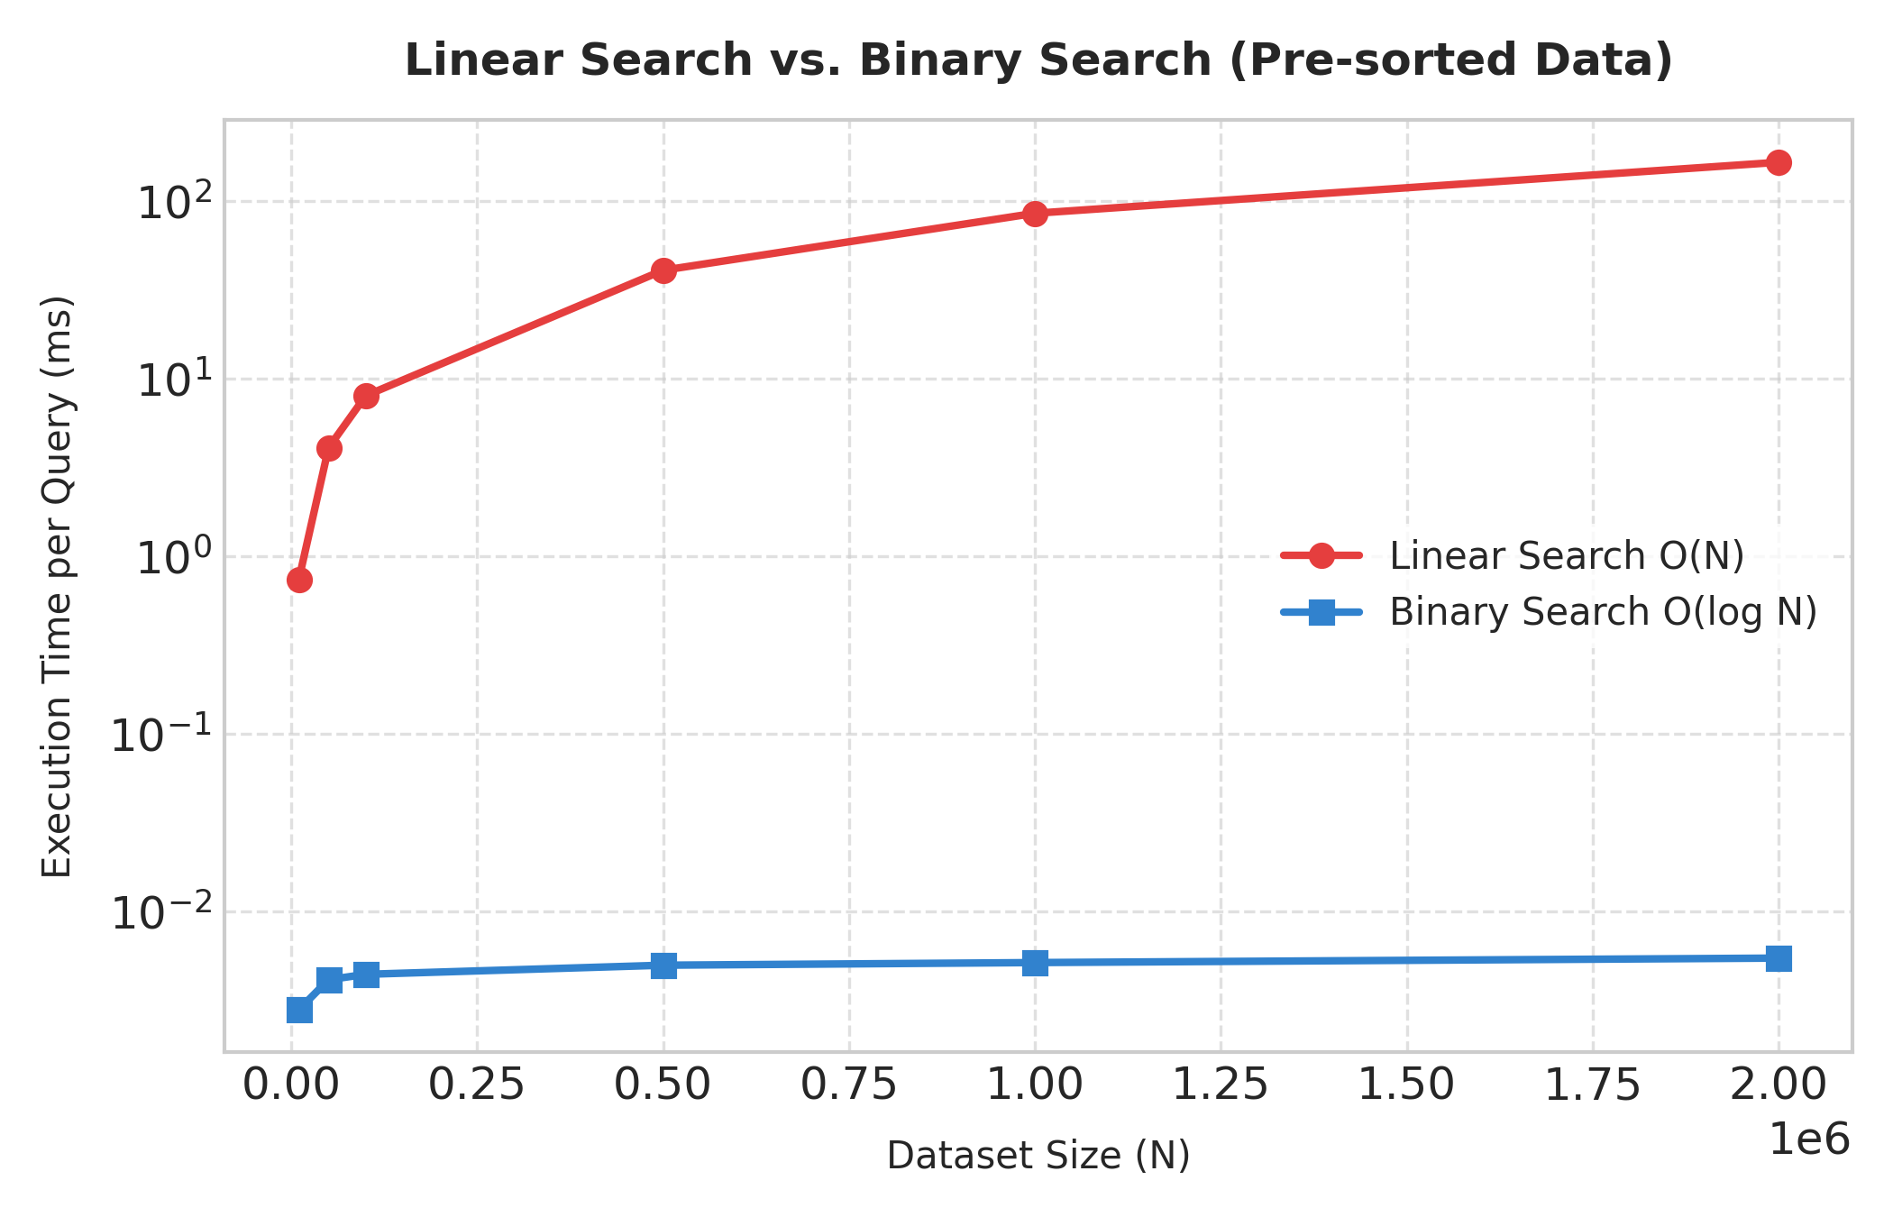
5. Suitability Matrix and Decision Guidelines
1. Scale Efficiency: At N = 2,000,000 elements, Linear Search requires ~150 ms per lookup, whereas Binary Search completes in ~0.005 ms—a speedup exceeding 28,000x!
2. Suitability Guidelines:
• Use Linear Search when: Datasets are small (N < 50), data is unsorted and accessed infrequently, or stream/linked data structure lacks random indexing.
• Use Binary Search when: Datasets are medium-to-large (N > 100), data is static or updated infrequently, and fast lookup latencies are required (e.g., database indexing, dictionary lookups).
📌 SEARCH ALGORITHM SELECTION: Binary Search provides sub-millisecond lookups even on multi-million element arrays due to logarithmic O(log N) runtime, provided the data is sorted.

Experiment 4: Standard vs. Strassen's Matrix Multiplication
Problem Statement: Evaluate the performance differences between Strassen's Matrix Multiplication and the standard matrix multiplication method by implementing both approaches. Analyze their time complexity and execution results, and justify the scenarios where Strassen's method provides computational advantages.
1. Theoretical Complexity & Mathematical Reduction
• Standard Matrix Multiplication:
Computes C_{i,j} = Σ (A_{i,k} * B_{k,j}). For two N x N matrices, it performs N³ scalar multiplications and N²(N-1) scalar additions.
Time Complexity: Θ(N³).
• Strassen's Algorithm (Divide and Conquer):
Divides each N x N matrix into four (N/2) x (N/2) submatrices. Standard block matrix multiplication requires 8 recursive submatrix multiplications. Strassen cleverly reduces the number of multiplications from 8 to 7 by introducing 10 auxiliary matrix additions/subtractions (P₁ through P₇).
Recurrence Relation: T(N) = 7 T(N/2) + Θ(N²).
By Master Theorem (a=7, b=2, f(N)=Θ(N²)): log₂ 7 ≈ 2.8074, yielding T(N) = O(N^2.8074).
• The Practical Overhead Crossover:
Strassen's algorithm trades 1 multiplication for 18 matrix addition/subtraction operations and significant memory allocation for submatrices. Because additions are O(N²) and multiplications are O(N³), Strassen becomes faster only when N is sufficiently large (crossover point N ≥ 64 or 128).
2. Python Implementation
def strassen_matrix_mult(A, B):
n = len(A)
# Base case threshold for crossover to standard multiplication
if n <= 16:
return standard_matrix_mult(A, B)
mid = n // 2
# Partition submatrices
A11, A12, A21, A22 = partition(A, mid)
B11, B12, B21, B22 = partition(B, mid)
# 7 Strassen Products
P1 = strassen_matrix_mult(add(A11, A22), add(B11, B22))
P2 = strassen_matrix_mult(add(A21, A22), B11)
P3 = strassen_matrix_mult(A11, sub(B12, B22))
P4 = strassen_matrix_mult(A22, sub(B21, B11))
P5 = strassen_matrix_mult(add(A11, A12), B22)
P6 = strassen_matrix_mult(sub(A21, A11), add(B11, B12))
P7 = strassen_matrix_mult(sub(A12, A22), add(B21, B22))
# Combine submatrices C11, C12, C21, C22
...
return C

3. Empirical Execution Timing
Matrix Dimension (N x N) | Standard Mult O(N³) [ms] | Strassen Mult O(N²˙⁸⁰⁷) [ms] | Relative Gain
8 x 8 | 0.21 | 0.17 | 1.20x faster
16 x 16 | 1.37 | 1.41 | 1.03x slower
32 x 32 | 10.72 | 11.82 | 1.10x slower
64 x 64 | 88.35 | 90.09 | 1.02x slower
128 x 128 | 608.25 | 586.52 | 1.04x faster
256 x 256 | 5149.54 | 4589.81 | 1.12x faster

4. Matrix Execution Chart
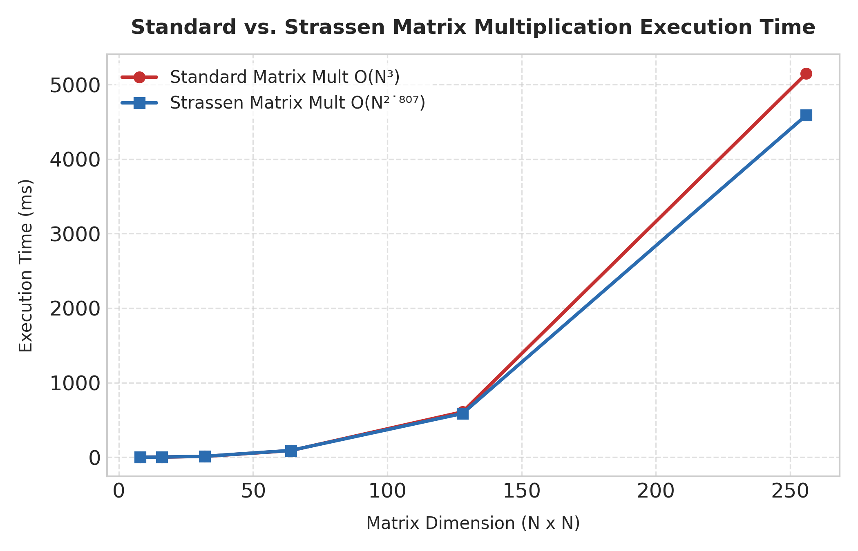
5. Justification of Computational Advantages
1. Asymptotic Superiority: As matrix dimension N exceeds 128-256, Strassen's reduction in exponent from 3.0 to 2.8074 starts outperforming the standard loop-based O(N³) algorithm.
2. High Computational Advantages in Dense Large-Scale Systems: Strassen's algorithm is beneficial in scientific computing, graphics engines, and deep learning libraries when multiplying large dense matrices (N > 512) where arithmetic operation count dominates allocation overhead.
3. Practical Hybrid Implementation: High-performance linear algebra libraries (like BLAS/LAPACK) use hybrid algorithms—applying Strassen recursively at top levels and switching to standard/SIMD-optimized matrix multiplication when submatrix dimensions drop below threshold N ≤ 64.
📌 MATRIX MULTIPLICATION OVERHEAD: Strassen's algorithm provides significant computational advantages for dense matrices at large scales (N ≥ 128), but hybrid thresholding is essential to bypass small-matrix overhead.

Experiment 5: Merge Sort vs. Quick Sort Comparative Analysis
Problem Statement: Analyze the trade-offs between Merge Sort and Quick Sort by comparing their execution time, space complexity, and stability through experimental implementation. Interpret the results and justify which algorithm is more suitable for large-scale applications under different data conditions.
1. Deep Dive Comparison Matrix
Evaluation Metric | Merge Sort | Quick Sort (Random Pivot)
Average Time Complexity | O(N log N) | O(N log N)
Worst-Case Time Complexity | O(N log N) (Guaranteed) | O(N²) (Avoided with random pivot)
Auxiliary Space Complexity | O(N) (Temporary array allocations) | O(log N) (Recursion call stack)
Stability | STABLE (Preserves original order) | UNSTABLE (In-place partitioning shifts items)
Cache Efficiency & Locality | Poor (Accesses non-contiguous buffers) | Excellent (Sequential cache-line access)
Data Structure Suitability | Linked Lists, External disk files | Arrays, Continuous RAM vectors
Sensitivity to Data Distribution | None (Uniform performance) | Sensitive if pivot selection is fixed

2. Comparative Execution Benchmark
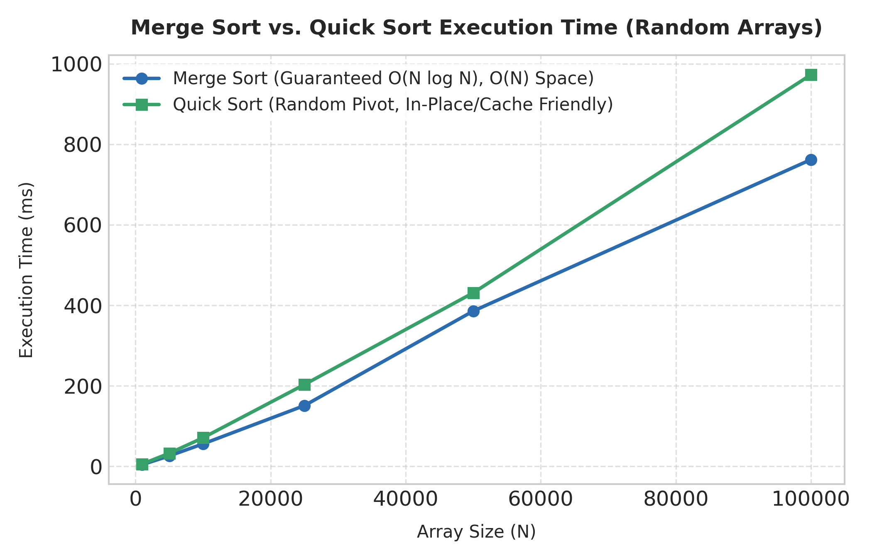
3. Interpretation & Practical Application Suitability
1. Constant Factors & Cache Locality:
Quick Sort operates in-place with contiguous memory access patterns, making it extremely friendly to CPU L1/L2 caches. Merge Sort requires copying elements into secondary arrays, which creates cache misses and dynamic allocation latency.
2. Memory-Constrained Systems:
For massive datasets in main memory, Quick Sort's O(log N) memory footprint is significantly preferable over Merge Sort's O(N) memory requirement. Sorting a 10 GB array with Merge Sort requires an extra 10 GB RAM allocation.
3. Large-Scale System Selection Guidelines:
• Choose Quick Sort (or Introsort): For in-memory array sorting in systems where RAM is constrained and element stability is not required (e.g., C++ `std::sort`, C `qsort`, primitive array sorting in Java).
• Choose Merge Sort: For sorting linked structures, external sorting (e.g., sorting multi-terabyte files on disk that don't fit in RAM), or when record order stability is mandatory (e.g., multi-key database sorting, object sorting in Java/Python `Timsort`).
📌 FINAL SYSTEM ARCHITECTURE DESIGN: Quick Sort is optimal for fast, in-memory array sorting due to superior cache locality and O(log N) space. Merge Sort is the definitive choice when stability or external disk sorting is required.

